**Admission Chatbot**

**Submitted by**

**Group: GA2**

**Brahm Dev Pandey - University Roll No: 2100290140052**

**Anuj Dubey - University Roll No: 2100290140031**

**Atif Ali - University Roll No: 2100290140040**

**Session: 2022-23(4th Semester)**

**Under the supervision of**

**Mr. Prashant Agarwal**

**Associate Professor**

**KIET Group of Institutions, Delhi-NCR, Ghaziabad**



**DEPARTMENT OF COMPUTER APPLICATIONS**

**KIET GROUP OF INSTITUTIONS, DELHI-NCR, GHAZIABAD-201206**

(April 2023)

**ABSTRACT**

Potential students' correspondence with a college department is handled manually, which takes a lot of time. It is highly important to have one-on-one interactions with people. Unfortunately, due to the large number of applications received each year, one-on-one interactions are rarely possible. A member of the academic staff will need to dedicate many hours to the communication in order to contact each student and discover appropriate answers. His costs and time might be cut, which would be beneficial.

By creating a persuasive chatbot, the project hopes to lighten the load on the head of admissions and perhaps other users. In order to search through the collection of data and maybe locate an answer, an appropriate algorithm must be created. If the user is not pleased with the response, the computer responds and offers a pertinent web link. Users also have access to a web interface.

The project's accomplishments can be summed up as follows. A literature review was conducted to prepare the project's backdrop. The system's criteria were created, and a variety of methods and tools, including keyword and template matching, were looked into. The technique employed combines string similarity with keyword matching. The suggested algorithm has been implemented in a workable system. The system was assessed using input from prospective students who utilised it as well as question and answer records.

**TABLE OF CONTENTS**

1. Introduction
2. Literature Review
3. Project Objective
4. Technologies Used
5. Hardware requirement and Software requirement
6. Modules Description
7. Reports
8. Gantt Chart
9. References

**INTRODUCTION**

Although the admissions procedure currently in place is effective, getting in touch with a college staff person is exceedingly time-consuming and challenging. Yet, if the applicant could speak to a convincing chatbot, able to address their concerns with information on admissions, hostel amenities, paying fees in installments, and what courses are offered, the problem might be partially resolved.

The chatbot should be able to communicate with a user in a way similar to the following:

User: Hello!

ChatBot: Hello, how can I help you?

User: What are the courses offered by your college?

ChatBot: KIET provides B.Tech, B.Pharma, MCA, MBA, M.Pharma

User: What is the percentage criteria to take admission in MCA?

ChatBot: Student must have Bachelors degree with minimum 60 percentage and with no backlog.

User: What is the fees for MCA?

ChatBot: Total yearly fees of MCA is Rs. 1,38,500 /-

User: Is there any concession for economically weaker students?

ChatBot: Meritorious students can get fee waiver seats and also students can fill UP Scholarship form.

User: Thank you!

ChatBot: Thanks for visiting our website. Have a nice day!

**LITERATURE REVIEW**

1. **“Natural Language Processing in Artificial Intelligence” by Brojo Kishore**

The aim of this edited book is to foster interactions among researchers and practitioners in NLP, AI, and allied areas. The edited book covers theoretical work, advanced applications, approaches, and techniques for computational models of information and its presentation by language(artificial, human, or natural in other ways). The goal is to promote intelligent natural language processing (NLP) and related models of thought, mental states, reasoning, and other cognitive processes.

1. **“Graph-based Natural Language Processing and Information Retrieval”**

This book is a comprehensive description of the use of graph-based algorithms for natural language processing and information retrieval. It brings together areas as diverse as lexical semantics, text summarization, text mining, ontology construction, text classification, and information retrieval, which are connected by the common underlying theme of using graph-theoretical methods for text-and information-processing tasks.

1. **“Automation, Innovation and Work”**

This book explores the impact that these intelligent robots and intelligent in formats will have on social and societal development. The author tackles the question of singularity from three distinct standpoints: technological singularity – the intelligence of machines compared to that of humans – which he argues will bring about a qualitatively new labour market; economic singularity – the consequences for work relationships, value creation and employment – which he asserts will promote full automation, result in precarious contracts with low salaries, and, in some countries, possibly lead to the introduction of a universal basic income; and social singularity – the consequences of technological and economic singularity for democratic processes, bureaucratic procedures for exercising authority and control, and the direction in which society will develop.

1. **“Applied Machine Learning for Smart Data Analysis” by N Dey**

Applied machine learning for smart data analysis is a practical guide for anyone interested in using machine learning techniques to analyze and understand data. The book covers the basics of machine learning, including data preparation, feature selection, and model evaluation. It also includes in-depth discussions of popular machine learning algorithms such as decision trees, logistic regression, and support vector machines. The book is designed to be accessible to readers with a basic understanding of statistics and programming, and includes examples and case studies from a variety of fields, including finance, healthcare, and social media. Overall, "Applied Machine Learning for Smart Data Analysis" is a useful resource for anyone looking to use machine learning to gain insights from data.

1. **“Adversarial Machine Learning” by D. Joseph**

Adversarial Machine Learning is a comprehensive guide that explores the field of adversarial machine learning, which is concerned with the vulnerability of machine learning models to malicious attacks. The book covers a wide range of topics, including different types of attacks that can be launched against machine learning models, such as evasion and poisoning attacks. It also discusses the defense mechanisms that can be employed to mitigate these attacks, such as adversarial training, data sanitization, and model verification. The book is intended for readers with a strong background in machine learning and is well-suited for researchers, academics, and practitioners interested in the security and robustness of machine learning models. Overall, "Adversarial Machine Learning" provides a comprehensive overview of this emerging field and is a valuable resource for those looking to gain a deeper understanding of the potential vulnerabilities and defenses in machine learning systems.

1. **“Design of Intelligent Applications using Machine Learning and Deep Learning Techniques” edited by Ramchandra Sharad Mangrulkar**

This book is a comprehensive guide that provides insights into the design and development of intelligent applications using machine learning and deep learning techniques. The book covers a broad range of topics, including data preparation, feature selection, model selection, and evaluation, as well as deep learning techniques such as convolutional neural networks and recurrent neural networks.

The book includes contributions from a variety of experts in the field and covers applications in diverse fields such as healthcare, finance, and marketing. The authors provide practical examples and case studies to illustrate how machine learning and deep learning can be used to build intelligent applications that can make predictions, classify data, and automate tasks.

1. **“Supervised Machine Learning: Optimization Framework and Applications with SAS and R” by Tanya Kolosova and Samuel Berestizhevsky**

This book is a practical guide that provides a comprehensive overview of supervised machine learning and its applications using the SAS and R programming languages. The book covers the foundational concepts of supervised machine learning, including regression, classification, and decision trees.

The authors provide detailed explanations of optimization frameworks and how they can be applied to various supervised machine learning algorithms, such as linear regression, logistic regression, and support vector machines. The book also covers practical applications of supervised machine learning in various fields, such as finance, healthcare, and marketing.

1. **"Practical Guide to Logistic Regression" by Joseph M. Hilbe**

This book is a comprehensive guide that provides practical insights into logistic regression, a popular statistical method used for analyzing binary and categorical data. The book covers the foundational concepts of logistic regression, including model formulation, estimation, and model evaluation.

The book is designed for readers with a basic understanding of statistics and regression analysis and provides a useful resource for researchers, students, and practitioners interested in using logistic regression for data analysis.

1. **“Bayesian Modeling and Computation in Python” by Osvaldo A. Martin, Ravin Kumar, Junpeng Lao**

The book is designed for readers with a basic understanding of statistics and programming and provides a useful resource for researchers, students, and practitioners interested in using Bayesian modeling and computation for data analysis. Overall, "Bayesian Modeling and Computation in Python" is a valuable resource for those looking to gain a deeper understanding of Bayesian modeling and its practical applications using the Python programming language.

1. **"Data Science and Analytics with Python" by Jesus Rogel-Salazar**

is a comprehensive guide that provides practical insights into data science and analytics using the Python programming language. The book covers the foundational concepts of data science, including data cleaning, data visualization, and exploratory data analysis.

The author provides a step-by-step approach to building and interpreting machine learning models using various Python libraries, including NumPy, Pandas, Scikit-Learn, and Matplotlib. The book also covers practical applications of data science and analytics in various fields, such as finance, healthcare, and social sciences.

**PROJECT OBJECTIVE**

The goal of this project is to build a chatbot that students may utilise to quickly get answers to their questions from the college website. A chatbot is a computer software that can conduct real conversations using text and/or audio. Making Use of Artificial Intelligence (AI),

Chatbots are programmes that mimic human speech. The two types of chatbots are as follows. One category of chatbots that operate under commands and rely on a database of responses is heuristics. While posing inquiries to the bot, the user must be very explicit. As a result, these bots are only capable of doing a small number of tasks. External to the code. The second group consists of AI- or machine-learning-based chatbots. These bots may respond to ambiguous inquiries using algorithms, so the user does.



Building

a

response

Identify

intents

and

entities

Analyzing the request

Fig.: 1.1

The aim of this project is to contribute to the solution of the problem of direct communication between applicants and the college. The main objectives of the project are as follows:

To develop a web interface which aims to give the ability to potential students and their families to submit questions in a chatbot and get convincing replies.

**TECHNOLOGIES USED**

The technologies used for developing this project are:

* **Python (Flask)** - for developing the backend of the project

A high-level, all-purpose programming language is Python. Code readability is prioritised in its design philosophy, which makes heavy use of indentation. Python uses garbage collection and has dynamic typing. It supports a variety of programming paradigms, including procedural, object-oriented, and functional programming as well as structured programming (especially this). Due to its extensive standard library, it is frequently referred to as a "batteries included" language. Python was created by Guido van Rossum in the late 1980s to replace the ABC programming language, and it was originally made available as Python 0.9.0 in 1991. In 2000, Python 2.0 was made available. The 2008 release of Python 3.0 was a significant update that was only partially backwards compatible with previous iterations. The final Python 2 release was Python 2.7.18, which was made available in 2020. Programming language Python routinely ranks among the most popular ones.

* **ReactJS** - for developing the frontend of the project

React is a free and open-source front-end JavaScript toolkit for creating component-based user interfaces. It is also known as React.js or ReactJS. It is kept up-to-date by Meta (previously Facebook) and a group of independent programmers and businesses.

Using frameworks like Next.js, React can be the foundation for single-page, mobile, or server-rendered applications. Nevertheless, as React is mainly focused on the user interface and displaying components to the DOM, extra libraries for routing as well as specific client-side functions are typically needed when developing React apps.

**HARDWARE & SOFTWARE REQUIREMENTS FOR DEVELOPING THE PROJECT**

#### **Hardware Requirements**

|  |  |
| --- | --- |
| **S. N.** | **Description** |
| 1 | PC with 10 GB or more Hard disk. |
| 2 | PC with 2 GB RAM. |
| 3 | PC with core i3 or above processor. |

**Software Requirements**

|  |  |  |
| --- | --- | --- |
| **S. N.** | **Description** | **Type** |
| 1 | Operating System | Windows 10 or 11 or Ubuntu 18.04 or above |
| 2 | Language | Python 3 |
| 3 | Front End | React 17 |
| 4 | IDE | Google Colab, VS Code |
| 5 | Browser | Chrome, Firefox, Edge |

**MODULES IN PROJECT**

**Frontend**

* Login and Sign up – for logging in or signing up for an account
* Chat – for chatting with the bot
* See previous chats – for viewing your previous chats

**Backend**

* API in flask
* Chat intent classification
* Machine Learning model for answering queries
* Adding new chats

**REPORTS**

This project will have the following reports:

* Comparison of accuracy of various ML models used for intent classification
  + Logistic Regression Model
  + Gaussian Naive Bayes Model
  + K-Nearest Neighbours (KNN) Model
  + Recurrent Neural Network (RNN) Model
* Various sources of Questions collection
  + Questions from Google searches
  + Questions from popular admission websites
  + Questions collected from survey through Google Forms

**FLOW CHART**

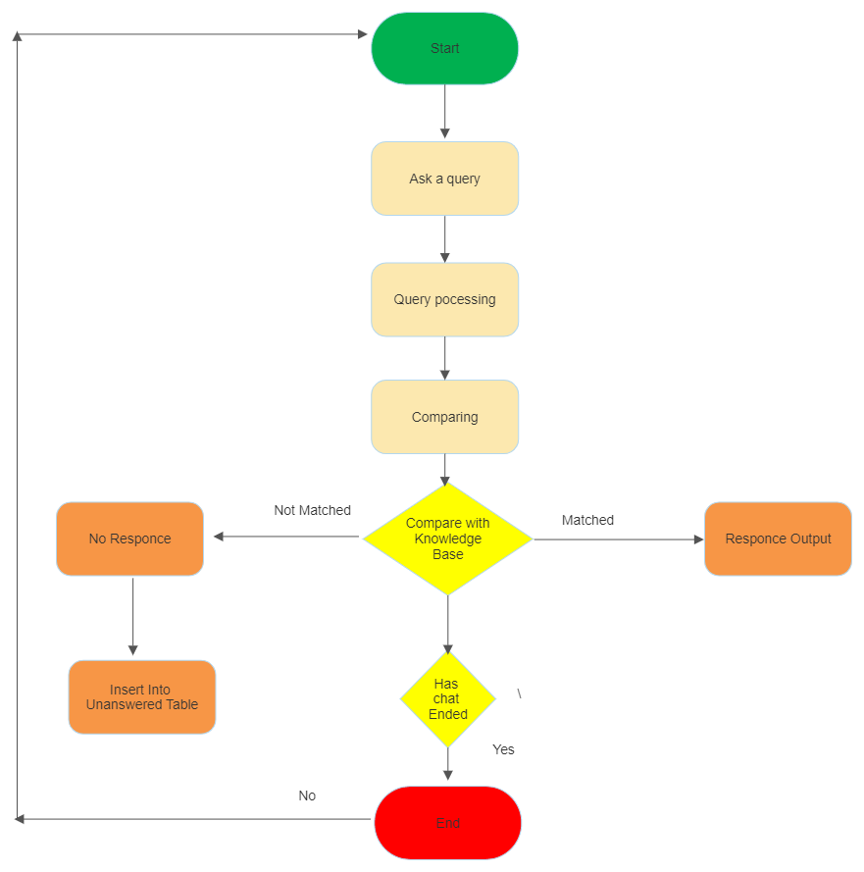

**GANT CHART**

**REFERENCES**

**E-books**

1. <https://books.google.co.in/books?hl=en&lr=&id=tAn-DwAAQBAJ&oi=fnd&pg=PP1&dq=Natural+Language+Processing+in+Artificial+Intelligence+Edited+ByBrojo+Kishore+Mishra,+Raghvendra+Kumar&ots=jZgTTIWJT6&sig=ifbcy0xxRI2Gx8V0EdVLija2boM&redir_esc=y#v=onepage&q=Natural%20Language%20Processing%20in%20Artificial%20Intelligence%20Edited%20ByBrojo%20Kishore%20Mishra%2C%20Raghvendra%20Kumar&f=false>
2. <https://books.google.co.in/books?hl=en&lr=&id=kByP4X9c5AQC&oi=fnd&pg=PA1&dq=Graph-based+Natural+Language+Processing+and+Information+Retrieval&ots=_EIeaeagYQ&sig=zsZwm5PCHToDjARJbtyVhze5q-E&redir_esc=y#v=onepage&q=Graph-based%20Natural%20Language%20Processing%20and%20Information%20Retrieval&f=true>
3. <https://books.google.co.in/books?hl=en&lr=&id=jRPWDwAAQBAJ&oi=fnd&pg=PT12&dq=Automation,+Innovation+and+Work+The+Impact+of+Technological,+Economic,+and+Social+Singularity+ByJon-Arild+Johannessen,+Helene+S%C3%A6tersdal&ots=23S8-08S3f&sig=42uQuCVDbaMTuUcRbV6gCZn9mW4&redir_esc=y#v=onepage&q&f=false>
4. <https://www.taylorfrancis.com/books/edit/10.1201/9780429440953/applied-machine-learning-smart-data-analysis-sanjeev-wagh-parikshit-mahalle-mohd-shafi-pathan-nilanjan-dey>
5. <https://www.cambridge.org/core/books/adversarial-machine-learning/C42A9D49CBC626DF7B8E54E72974AA3B>
6. <https://www.taylorfrancis.com/books/edit/10.1201/9781003133681/design-intelligent-applications-using-machine-learning-deep-learning-techniques-ramchandra-sharad-mangrulkar-antonis-michalas-narendra-shekokar-meera-narvekar-pallavi-vijay-chavan>
7. <https://www.taylorfrancis.com/books/mono/10.1201/9780429297595/supervised-machine-learning-tanya-kolosova-samuel-berestizhevsky>
8. <https://www.taylorfrancis.com/books/mono/10.1201/b18678/practical-guide-logistic-regression-joseph-hilbe>
9. <https://www.taylorfrancis.com/books/mono/10.1201/9781003019169/bayesian-modeling-computation-python-osvaldo-martin-ravin-kumar-junpeng-lao>
10. <https://www.taylorfrancis.com/books/mono/10.1201/9781315151670/data-science-analytics-python-jesus-rogel-salazar>

**Web Links**

1. <https://www.youtube.com/watch?v=-JOxupeIoMU&list=PLIRnO_sdVuEevLMSy7bE-Jaqyf1MK_wtr>
2. <https://www.coursera.org/learn/chatbot-rasa-python/ungradedLti/YEbTy/your-first-chatbot-with-rasa-and-python>
3. <https://medium.com/@avra42/build-your-own-chatbot-with-openai-gpt-3-and-streamlit-6f1330876846>
4. <https://en.wikipedia.org/wiki/Chatbot>
5. <https://www.geeksforgeeks.org/chatbots-using-python-and-rasa/>